Task 1: Data Breaches
Overview:
A data breach is an incident where information is stolen or taken from a system without the knowledge or authorization of the system's owner. Data breaches can occur as a result of a hacker attack, an inside job by individuals currently or previously employed by an organisation, or alternatively by unintentional loss of data.
Question 1:
Examine the screenshot below or alternatively navigate to:
https://www.informationisbeautiful.net/visualizations/worlds-biggest-data-breaches-hacks/
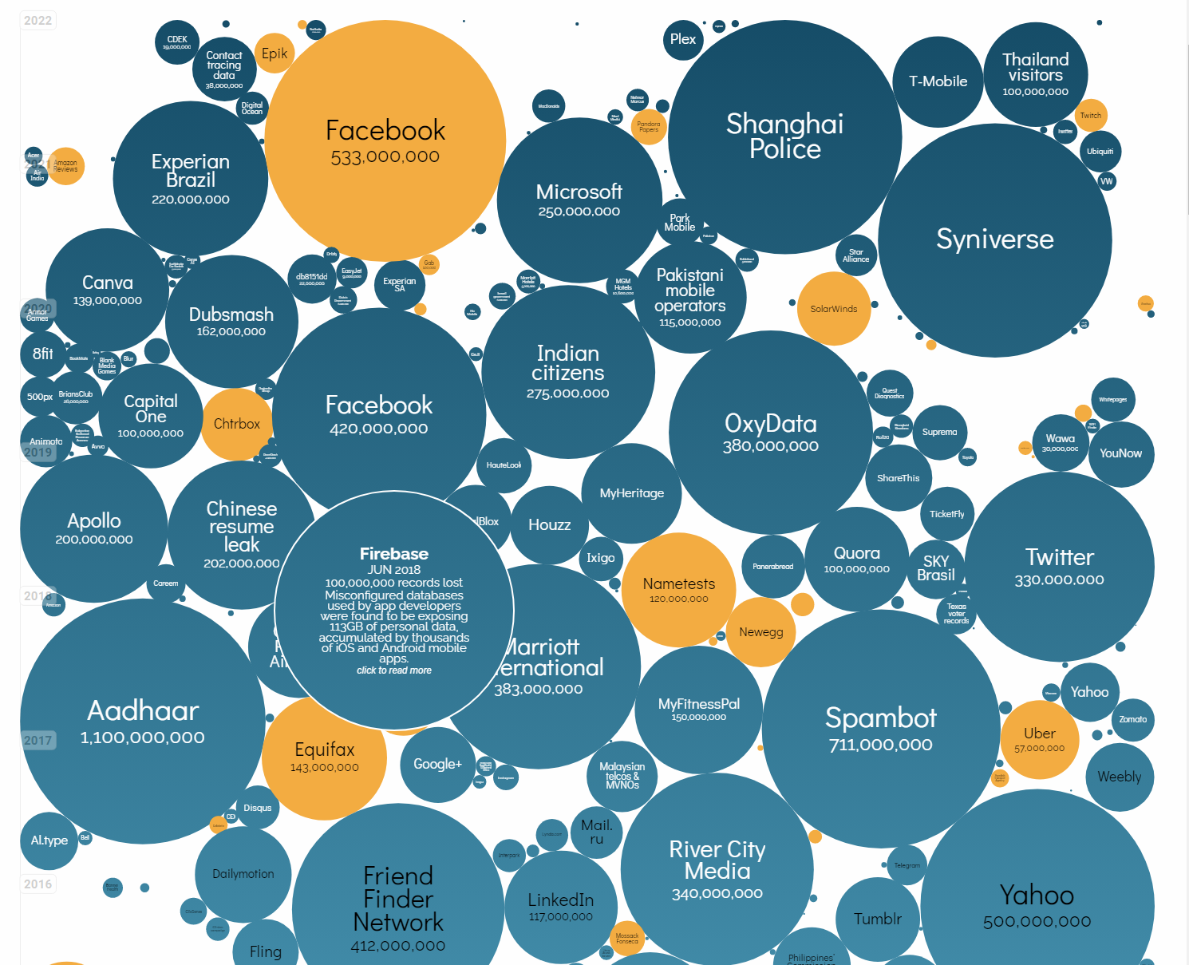
In the screenshot or alternatively on the website the size of the data breach is easy to
understand visually.

Individually or in groups examine the screenshot or the website and discuss and record your answers:

1. What is the largest data breach recorded?

2. From the companies listed that experienced a data breach, how many of them do you
recognise?

3. Are you surprised by any company you see on the list, were you aware of the data
breach?

4. Have you online accounts with any of the companies mentioned?

Question 2
Let’s check if your email or password has been disclosed as part of any data breach.
NOTE: The individual behind https://haveibeenpwned.com/ is a respected security professional, Troy Hunt, who took care to make sure it is a safe service to use by anyone wishing to learn if their data has been compromised and as such can be trusted. More information at https://haveibeenpwned.com/Privacy.
1.

Navigate to the Have I Been Pwned website https://haveibeenpwned.com/ and enter your email address.
- What do you see?
- Did you expect your email address to be safe/leaked? (Remember not to panic if
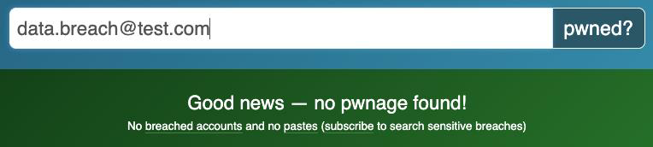
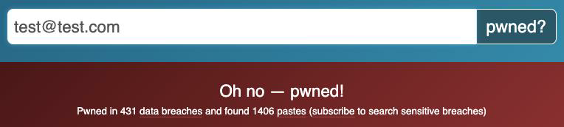
you see your email pop up in one of the breaches, steps to take if that happens are outlined in the slides!)

2.

Go to the ‘Passwords’ tab on the Have I Been Pwned website:
https://haveibeenpwned.com/Passwords and try entering some sample passwords.

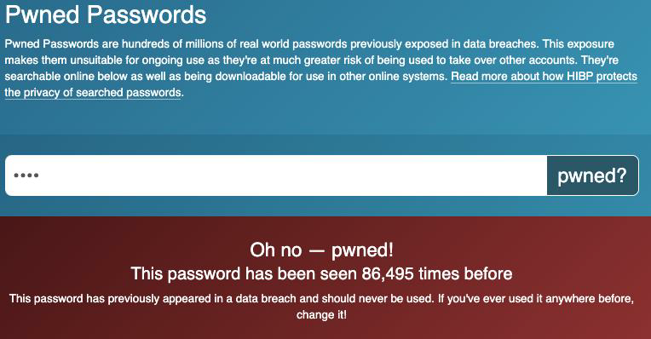
This tool will tell you if the password you entered has been leaked as part of a data breach. As an example, take the password ‘test’ that was entered in the screenshot below, it’s not very secure as it’s been found to be used through plenty of data breaches before!

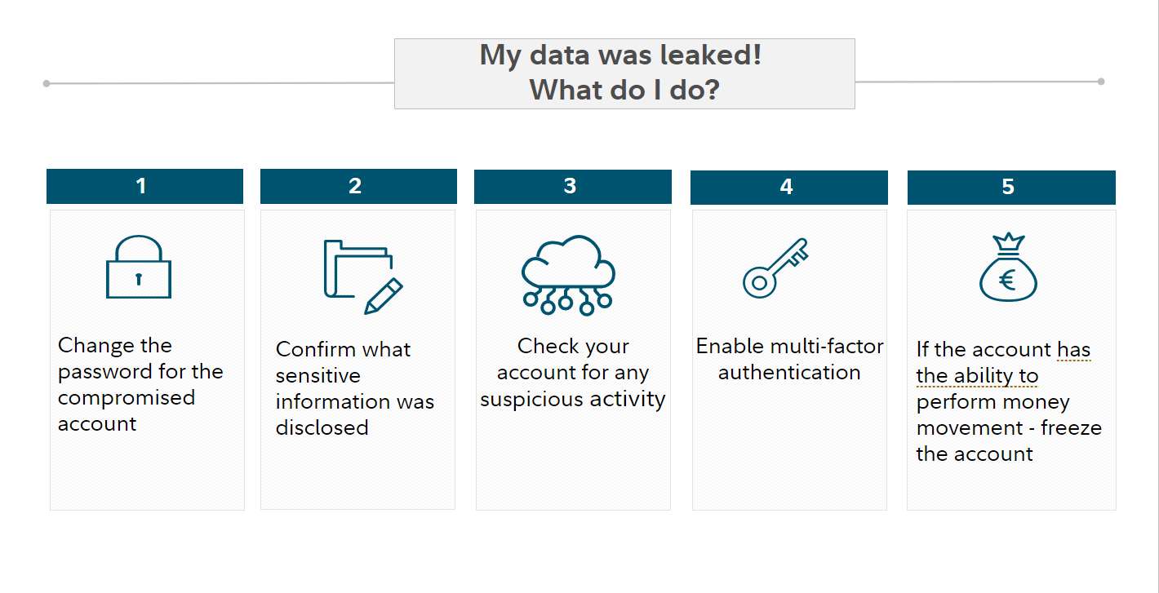
Remember if you determine that one of your accounts has been compromised by a data breach, do not panic! Follow the 5 steps below:

